**Department of Computer Applications**

**II MCA – 23MX26 Java Programming Lab Practice Test 1**

**SET B**

**Date:19.02.2024 Duration: 120 mins Marks: 25**

1.

Writing a program which will give you a chance to use random number generators together with a list of known values. Create a program that generates a secure password. Prompt the user for the minimum length, the number of special characters, and the number of digits. Then generate a password for the user using those inputs randomly.

An example of running this program would be:  
*What’s the minimum length? 8  
How many special characters? 2  
How many numbers? 2*

*How many passwords? 3*

*Your password 1 is: aurn2$1s#*

*Your password 2 is: ajar8@2n2%*

*Your password 3 is: sirk8@3ir\**

***Hint One:*** *You can assume that the following set of special characters can use used in generated passwords: ! " # $ % & ’ ( ) * + , - . / : ; < = > ? @ [ \ ] ˆ _ ‘ { | } ˜  
A simplest way to provide special characters to the program is to incorporate them into a (private final) string and a char-array which consists of all the above characters.****Hint Two:*** *The random selection requirement can be met by employing the class java.util.Random, and its nextInt(int) method. You will need to read the Random class API documentation in case if this class is somewhat of a novelty for you.*

*2.*

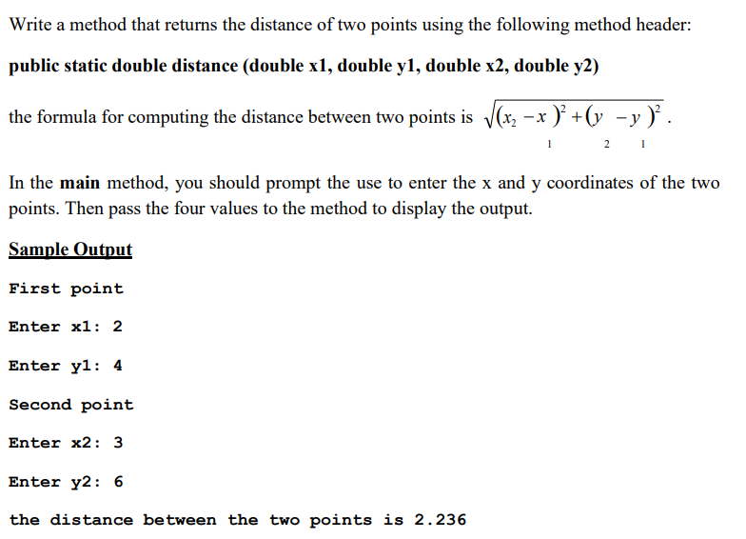

Repeat this task using sentinel control loop until user enters ‘N’ to not to continue.